PROJECT 2
Name: Ayodeji Idowu
Role: Data Analyst Intern
TASK: Exploratory Data Analysis (EDA)
This is the second project focused on the exploratory data analysis of the earlier cleaned dataset. The objective here is to find embedded insights, trends, and outliers in the cleaned dataset. The steps below are used to perform the EDA.
Step 1 – Create a folder for Project 2 - EDA
- Copy the cleaned Excel “SalesData” to the EDA folder.
- Create an additional column “Month” using the text formula =TEXT([@Date], "MMM")

Step 2 – Create a new Excel worksheet – Descriptive Statistics
- Extract the numeric columns for the dataset – Quantity, UnitPrice, ItemsInCart & TotalPrice to perform descriptive statistics
- Highlight the extracted data.
- Go to Data > Data Analysis >
- Select Descriptive Statistics in the dialogue box and click OK
- Input my Data range > Column & Label in First Row
- In the second part, select Summary Statistics
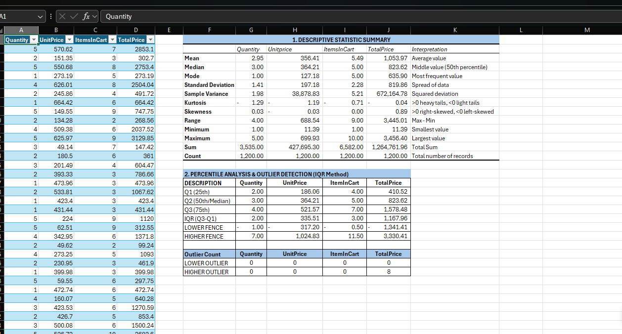
Step 3 – Percentile Analysis and Outlier Detection
This part was done using some percentile formulas for Q1, Q2 & Q3
- Create a table using the below formulas
- Q1 formula > =PERCENTILE.INC(SalesData[Quantity],0.25)
- Q2 Formula > =PERCENTILE.INC(SalesData[Quantity],0.5)
- Q3 Formula > =PERCENTILE.INC(SalesData[Quantity],0.75)
- IQR Formula > Q3-Q1

Step 4 – Analysing Categorical Distribution and Trends
- This analysis focuses on the categorical distribution columns in the dataset – Product, Month, PaymentMethod, OrderStatus, TrackingNumber, CouponCode, ReferralSource
- This was done using Excel formulas to get the impacts of the variables of the dataset.

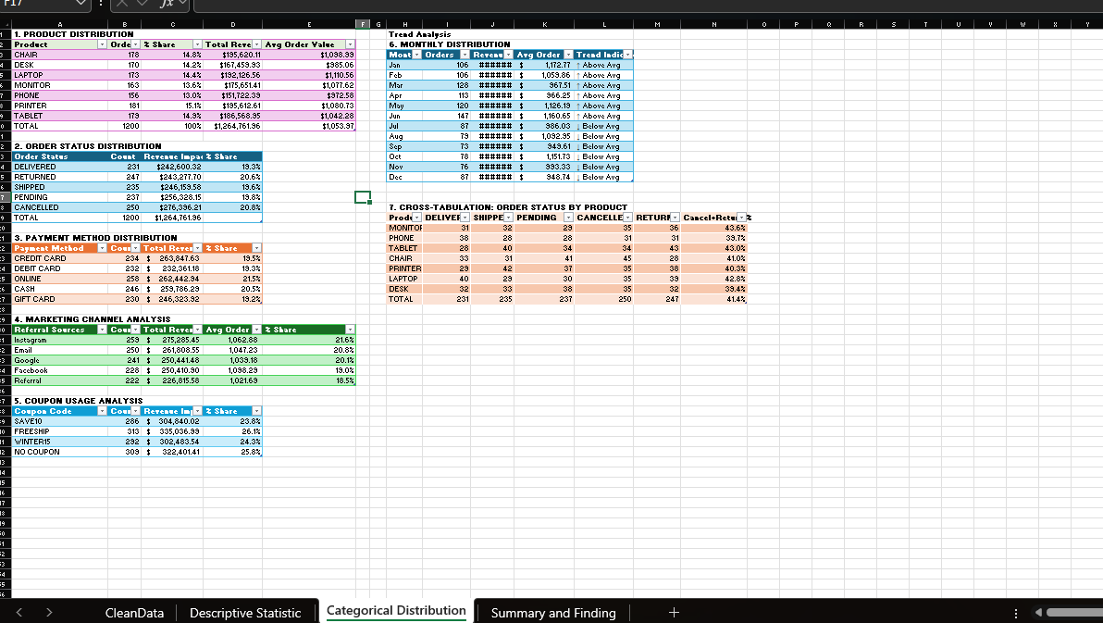

Step 5 – Summary and key findings
- There was a total of 1,200 orders with a potential total revenue of $1.26M.
- There was a critical finding of 41.6% of cancelled and returned orders, which is against the standard industry acceptable metrics of 5-10%. These could be due to quality and poor order satisfaction and need to be investigated further.
- Nearly half of all revenue is at risk from non-fulfilled orders
- Chair has the highest order volume but similar AOV to other products.
- Product mix is well-diversified (no single product dominates).
- Instagram leads in both volume AND revenue generation.
- Direct referral underperforms with 18% of revenue share
- Facebook shows the highest avg order value despite fewer orders
- Payment methods are evenly distributed (no dominant preference).
- June is the PEAK month for both orders and revenue.
- September shows the LOWEST activity - opportunity for promotional campaigns.
- Revenue variance across months indicates moderate seasonality

